

A&A 3D Print Request Form

**3D Printing Design Guide:**

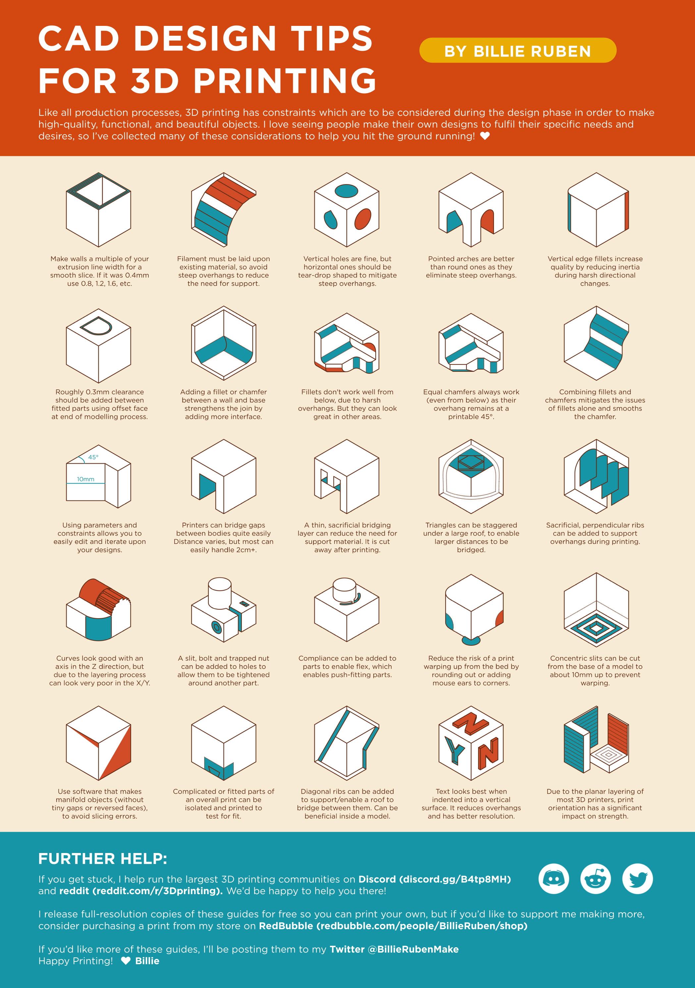General

https://twitter.com/Makertech3D/status/1036717700830179328

Layer Height – [More Information](https://all3dp.com/2/3d-printer-layer-height-how-much-does-it-matter/)  
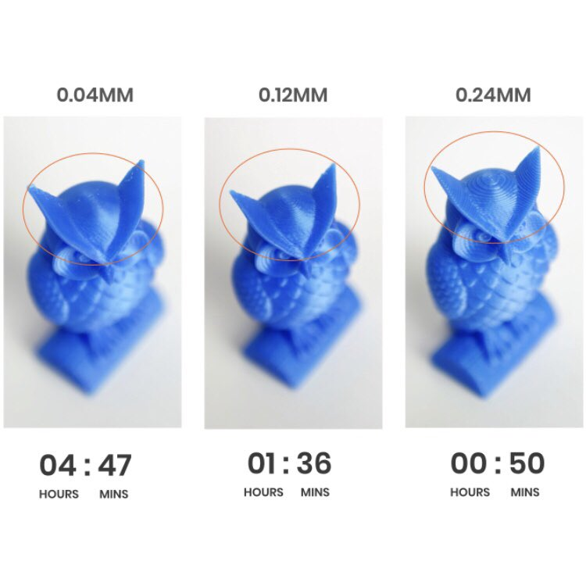

https://blog.adafruit.com/2020/01/24/a-poster-of-cad-design-tips-for-3dprinting-cad-billierubenmake/

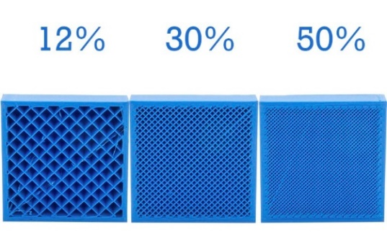  
Infill Percentage – [More Information](https://xometry.eu/en/infill-in-3d-printing/#:~:text=In%20most%20cases,%20an%20infill,and%20use%20too%20much%20material.)

https://filament2print.com/gb/blog/71_importance-infill-3d-printing.html

**Printing Acknowledgements**

I have read and reviewed the content in the 3D Printing Design Guide

I understand filament is only provided for Capstone Teams.   
 I understand if I am not in this category, I will need to supply my own filament.

**User Information**

First and Last Name: Click or tap here to enter text.

UW Email: Click or tap here to enter text.

RSO/Lab/Project: Click or tap here to enter text.

**Print Information**  
  
Please allow a minimum of 3 business days for submission to be printed

Requested Pickup Date: Click or tap here to enter text.

Print Materials include PLA, PETG, ABS*, and ASA* (*Ender 3 Only)

Material: Click or tap here to enter text.

Layer Height:  
 0.12mm – Detailed (Longer Lead Time)  
 0.16mm – Optimal  
 0.24mm – Draft (Quick Test Prints)

Infill Percentage:  
 15% (Default)  
 Click or tap here to enter text.

Additional Notes (Quantity of each Part to Print, Support Specifications, etc.):  
Click or tap here to enter text.

I have attached all of the required .stl files to my email.