**3D Printing Design Guide:**

**A&A 3D Print Request Form**

**Layer Height** – [More Information](https://all3dp.com/2/3d-printer-layer-height-how-much-does-it-matter/)

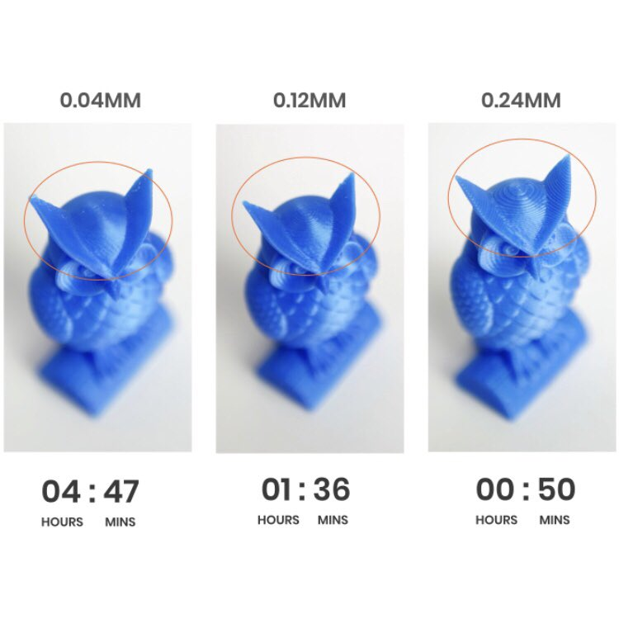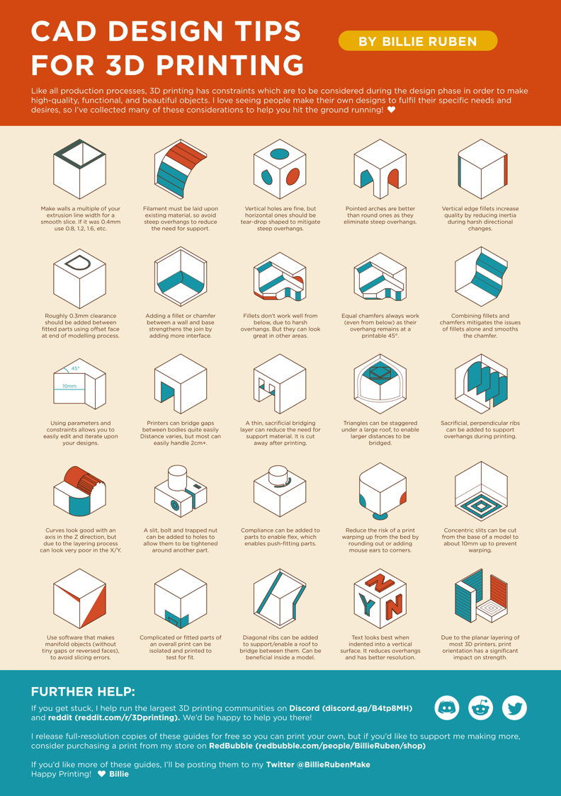**General**

https://blog.adafruit.com/2020/01/24/a-poster-of-cad-design-tips-for-3dprinting-cad-billierubenmake/

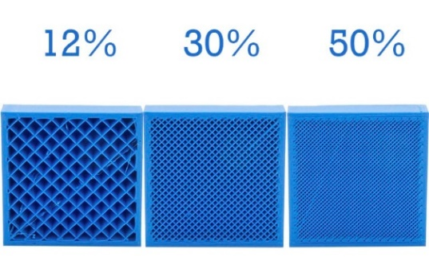

**Infill Percentage** – [More Information](https://xometry.eu/en/infill-in-3d-printing/#:~:text=In%20most%20cases,%20an%20infill,and%20use%20too%20much%20material.)

Print requests are completed using a   
Creality Ender 3 Printer.  
Click [here](https://3dprinting.com/products/3d-printer/creality-ender-3-2022/) to see specifications.

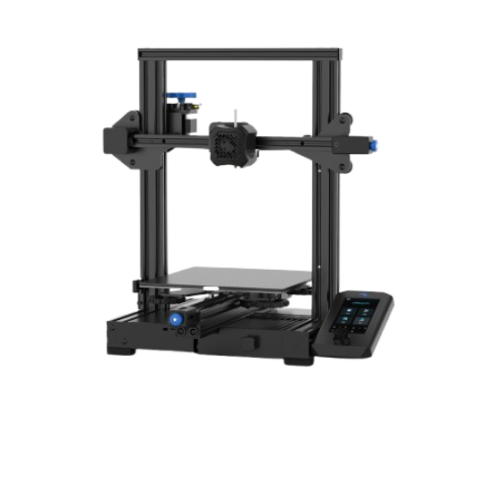

https://filament2print.com/gb/blog/71_importance-infill-3d-printing.html

**Printing Acknowledgements**

I have read and reviewed the content in the 3D Printing Design Guide

I understand filament is only provided for Capstone Teams.   
 I understand if I am not in this category, I will need to supply my own filament.

**User Information**

First and Last Name:

UW Email:

RSO/Lab/Project:

**Print Information**

Please allow a **minimum** of 4 business days for submission to be printed

**Desired** Pickup Date:

Print Materials include PLA, PETG, and ABS

Material:

Layer Height:  
 0.12mm – Detailed (Longer Lead Time)  
 0.16mm – Optimal  
 0.24mm – Draft (Quick Test Prints)

Infill Percentage:  
 15% (Default)

Units of Exported .STL file:  
 Inches  
 Millimeters

Additional Notes (Quantity of each Part to Print, Support Specifications, etc.):

I have attached all of the required .STL files to my email.